Muhammad Ishaq
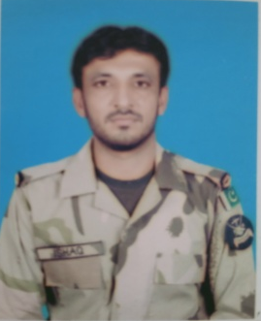
Basti sheikh,Mahrah gharbi P/O Mahrah Khas Tehs & Dist Muzafar garh
Mobile # 0300-0848438
OBJECTIVE:-
- My Objective is to fully utilized capabilities and experience with Honestly. Laving ability to work with group.
PERSONAL INFORMATION:-
- Father Name: Sheikh Muhammad Shafi
- Date of birth: 15-04-1989
- C.N.I No: 32304-0582623-7
- Nationality: Pakistani
- Language: English (Normal), Urdu, Punjabi, Saraiki
ACADEMIC QUALIFICATION:-
- Matriculation from D.G Khan Board (Punjab) (2nd Dvn)
- Recruit Clerk Course (RCC) Murree Koldana Law
EXPERIENCE:-

- 11-Yaer experience of Clerk Duty College (Retired from Pakistan Coast Guards on 31 November 2017) (CAF).
- 6x Month Basic Military Training from Pakistan Coast Guards (CAF)
COMPUTER SKILL:-

- MS Office from Koldana Murree Law College
- MS World
- MS Exile
- MS Power Point
- Computer hardware.

